Send a message to a channel in Teams
When you go to any channel in Teams the very first tab is Posts. Think of this as one big group chat. Everyone who has access to the channel can see the messages on the Posts tab.
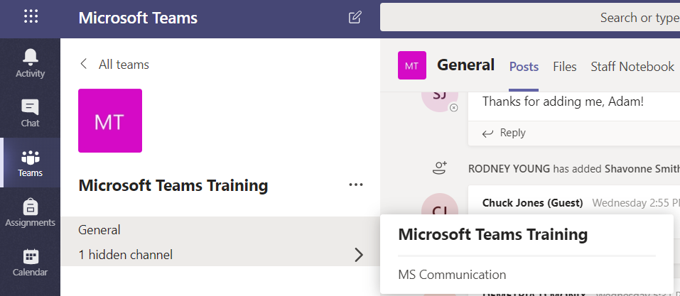
Channel

The other important thing to know about messages in a channel is that replies to a channel message stay attached to the original message. This way, the whole thread of the conversation can be easily followed by anyone reading it. This is the beauty of threaded conversations!
To reply to a channel message, select the little Reply link underneath the message.
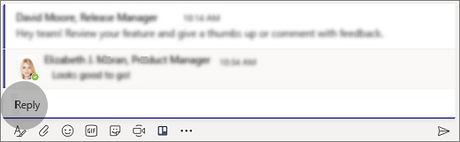
To send a message to everyone in a particular channel (the whole team), follow these steps:
First, select the channel you want. Then, click Reply to respond to an existing thread or go to the compose box at the bottom of the Posts tab to start a new one. Next, type your message in the box and select Send . Voila! Your message is now live in the channel.
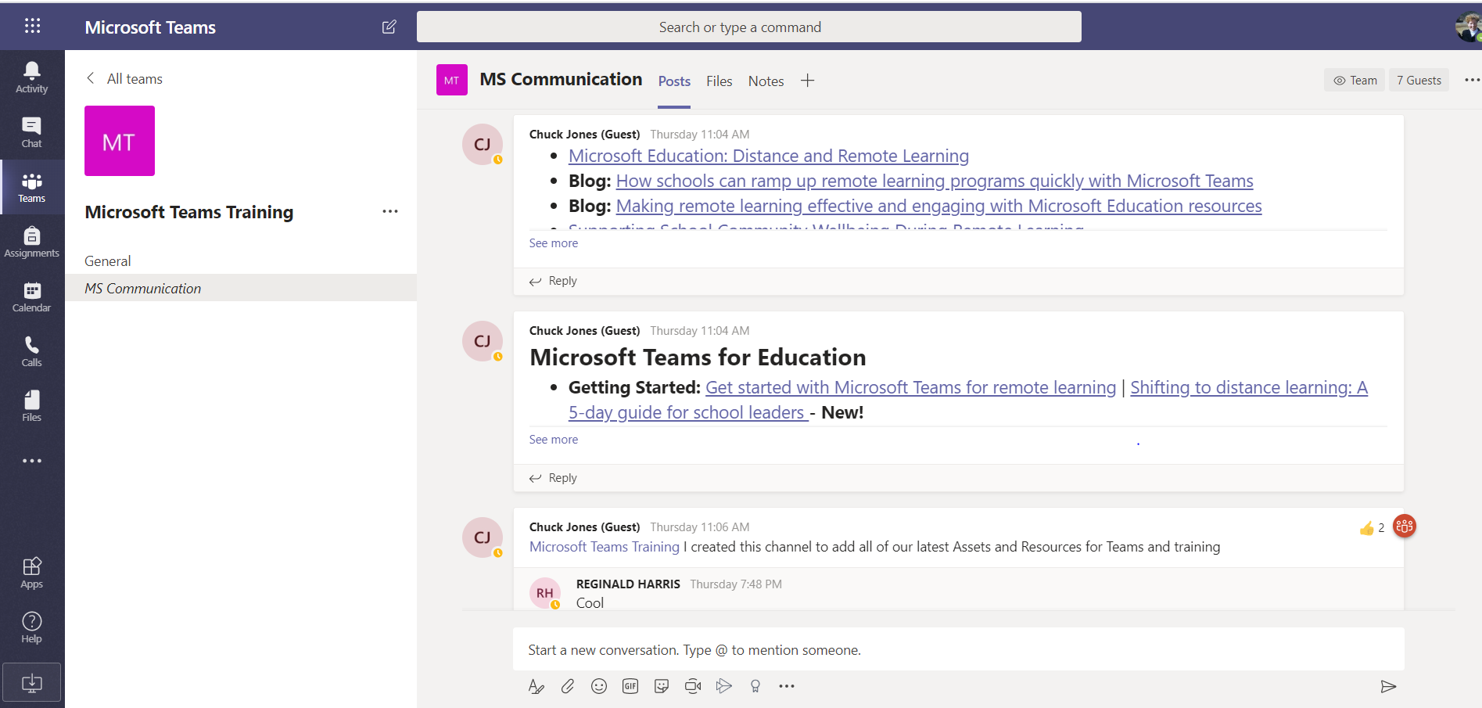
If you only want to talk to one person or a small group, see Start a chat in Teams.

